***Wander Earth – Android Mobile Application***

By:

**Rafi Al Mahmud**

**Roll: 1807119**

Course No: CSE 2200

Course Title: Advanced Programming

Under The Guidance Of:

|  |  |
| --- | --- |
| **Sunanda Das**  Lecturer  Department of Computer Science and Engineering  Khulna University of Engineering & Technology | **H. M. Abdul Fattah**  Lecturer  Department of Computer Science and Engineering  Khulna University of Engineering & Technology |



Department of Computer Science and Engineering  
Khulna University of Engineering & Technology  
Khulna, Bangladesh

**TABLE OF CONTENTS**

**Chapters**

1.Objectives3

2. Introduction3

2.1 Motivation3

2.2 Proposed System 3

2.3 Related Work 3

3.Implementation 4

3.1 Design Approach 4

3.2 Detailed Design 4

3.3 Appliction design 7

3.4 User Interface Design 8

3.5 Database Design (Schema Diagram)8

3.6 Detailed Visualisation 9

4.Target vs. Actual Accomplishments 11

5. Risk and Issues 11

6. Discussions 11

7.Conclusion 13

8. References 13

1.Objectives:

1. To assemble all hotels in one platform
2. To make travelling easier
3. To provide the ratings of hotel room
4. To provide all the services of Travel agencies

2. Introduction:

2.1 Motivation:

‘Wander Earth’ is a platform where consumers can get all hotels in one platform. They can also compare rooms by ratings and prices of hotels. Hotels also can provide their services through this applictaion. This will also reduce the hassle of renting an agency. Getting information for travellers will be more easier, more efficient.

2.2 Proposed System

People can select Country, District, Tourist spot respectively . Then wee will show the hotel list. After selecting a hotel we will show the rooms with ratings and price. Hotel can enter their room, room price and open booking in this app.

2.3 Related Works

Currently, there exist many applications which provide hotel services but not exactly what our application does. Our application helps people in saving their time. Traditional hotel apps in market only provides one hotel or one agency. On the contrary, our platform is a third party appliction, where the hotel will free to create their account (of course there will be a verification system for hotels).

3.Implementatin:

3.1 Design Approach:

This project is based on the functional design approach, which helps in understanding the design of the project in a simpler way by explaining its flow, use cases, and implementation more like a modular approach. For example, there are different modules in this project which have separate functionality and, other sub functionalities/modules. All the modules are designed, implemented and integrated together to make a flawless working application.

3.2 Detailed Design:

The detailed design including modules and sub modules of the application is as follows:

1. User Registration:

If the user wants to use the Wanter Earth, they must download the application from the play store, install and register it by providing login information. Once, they registers the registered information is stored on the server and can be validated, checking the valid credentials for the next time he logins with the application. Note that there will be two types of member type during sign up: Hotel and Consumer Account.

2.Select Hotel for Consumer:

In consumer account there is a spinner for selecting hotels. The hotels which has opened their booking will be shown on this module.

1. See rooms for Consumer:

After selecting hotel user will click on see room button, they will select the date from calender. The rooms will be shown, if booking is open on the selected date. Note that the booked room color is green, otherwise it is yellow.

1. Checkout and Payment:

If a user click on unbooked rooms (yellow color) , a dialogue box will open for the confirmation of payment . If the user proceed it will take them another activity for payment. If the user pay the amount the room will be booked, balance will added to the hotel account. Rooms that has booked (green color) can’t be booked further .

1. Give Rating of Rooms for Consumer:

If a consumer click on booked room ( green color) there can be two things: booked by him/her and booked by others. If he booked the rooms a dialogue box will open to take the rating. A user can give rating only one time for one booking. If the room is booked by others, nothing will heapen (a toast will show that the room is booked).

6.Enter Room Properties and Open booking for hotel:

In hotel account a hotel can enter their room properties ( room no, floor no, averege room prize). In this version, the hotel can enter these properties only one time (room properties can edit in the future update). The user can open booking by selecting to the date till which booking will be opened (from today).

7.Mark room as booked for Hotel:

If a room booked in offline the hotel can marked the room as booked. If the booking canceled, the hotel can mark the room as unbooked.

8.Change & Forget Password:

Users can update their password by entering the old password. If a user forget the password, he can update the password by email authantication.

3.3 Appliction design:

The main aim of the system design is to explain the scenario using use case diagrams. Use case diagrams clarify the flow of the application by deriving the use cases for all the functionalities in form of diagrams for the users.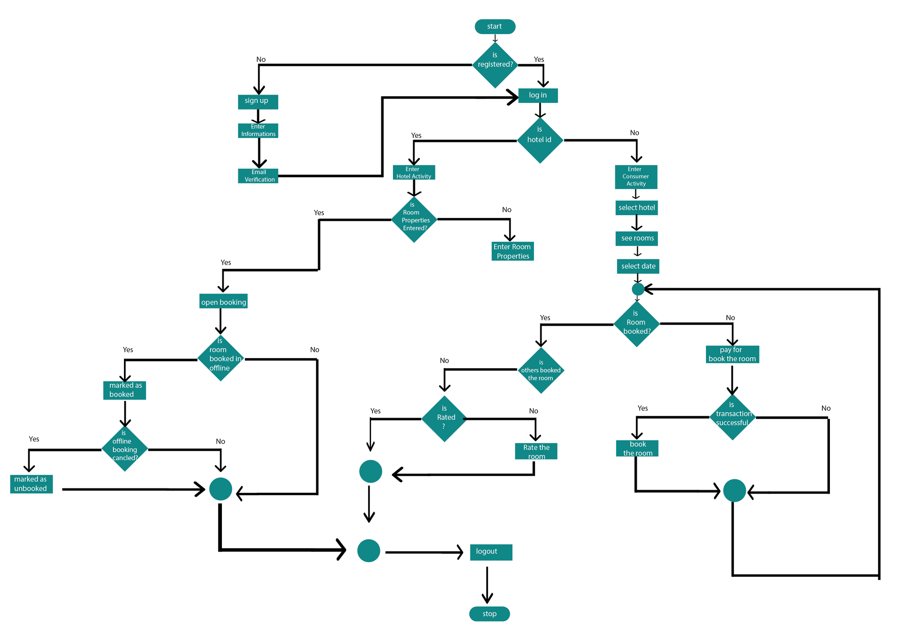Figure: floachart of the system

3.4 User Interface Design:

User Interface Design for any application should be very simple. We should have only a few clicks or navigation among the features when using the application to avoid hassle. After register and login, the consumer can book a room with only 5 clicks. The hotel can open booking with only two clicks.

3.5 Database Design (Schema Diagram):

The database should be designed in such a way that it should be easy to access and manipulate. Database definition and database manipulation operations should be performed accordingly to add, delete, and update values. In this project, I have used a Firebase database which is free for 30days in test mode, easy to install and use. The schema diagram of database in given below:

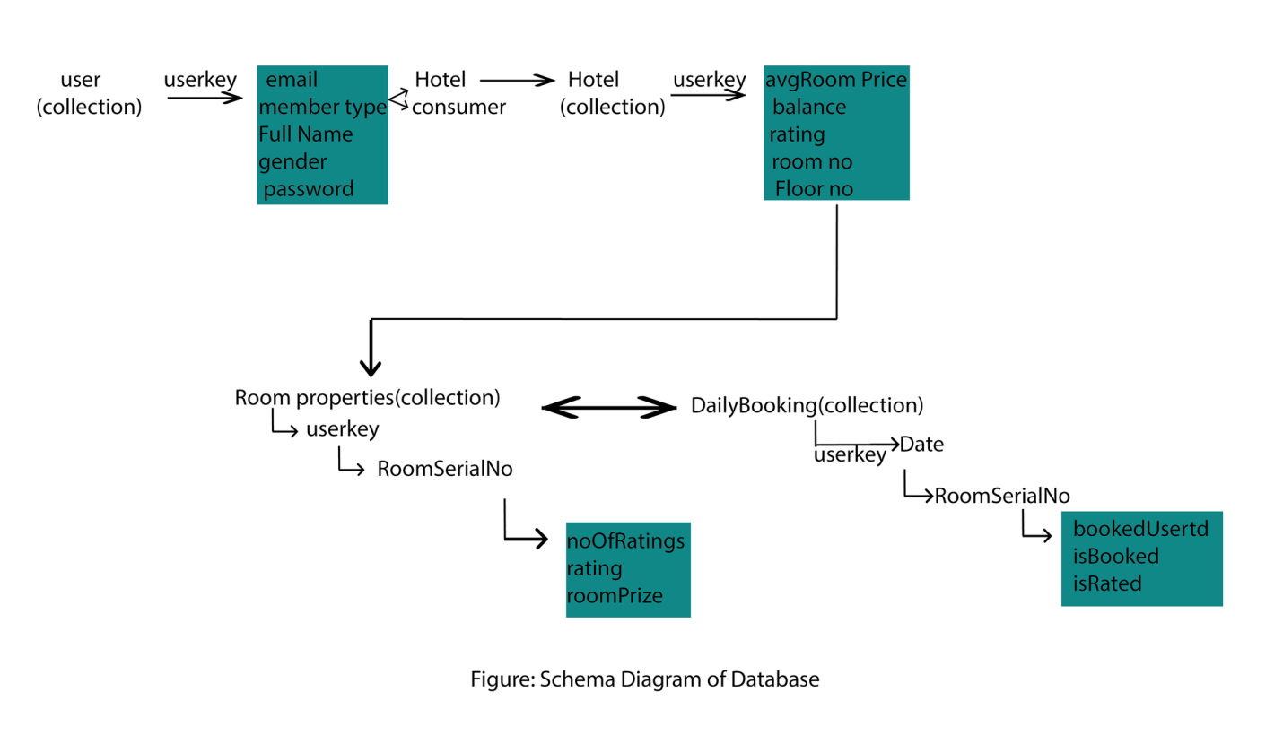

3.6 Detailed Visualisation:

The Visualization of User Interface is given bellow: 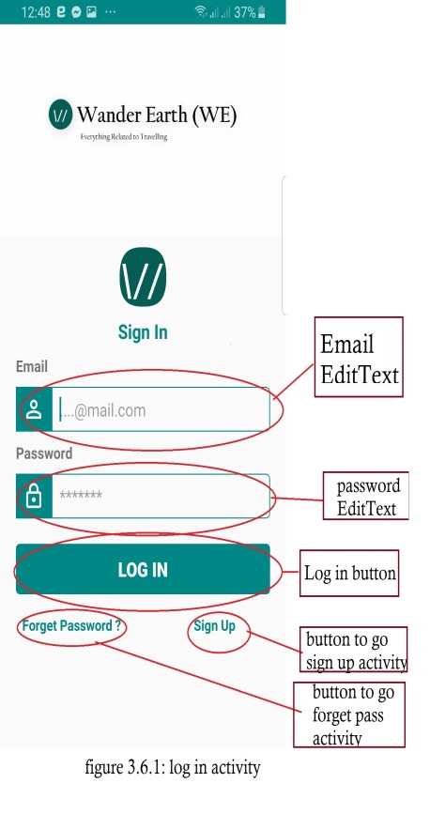 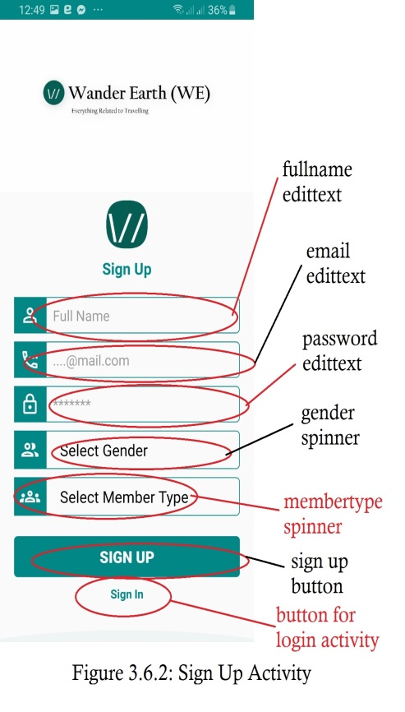 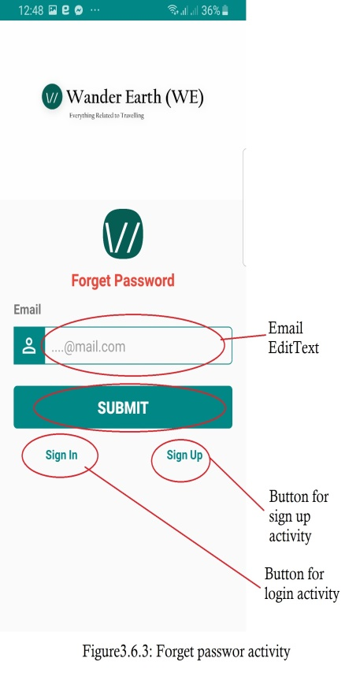 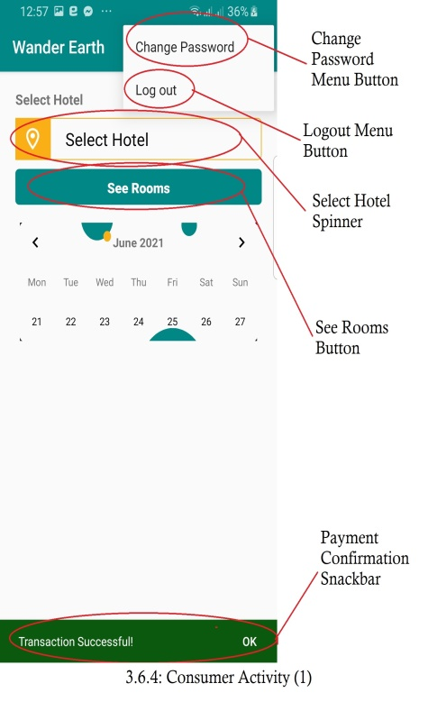 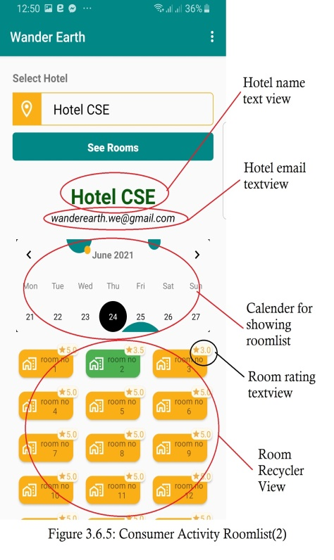 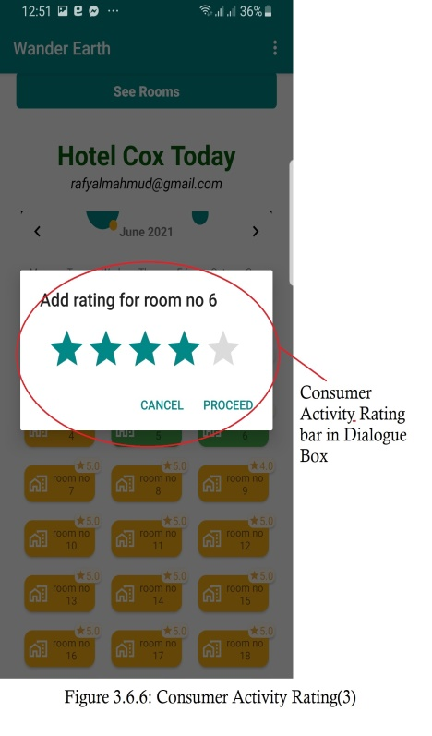 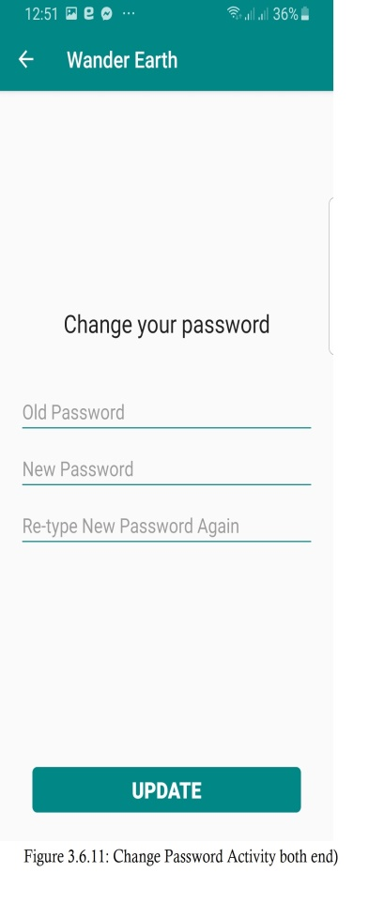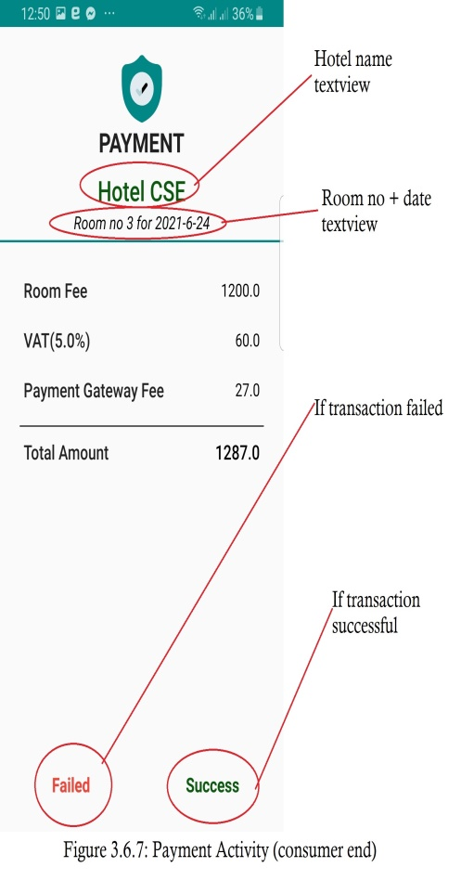 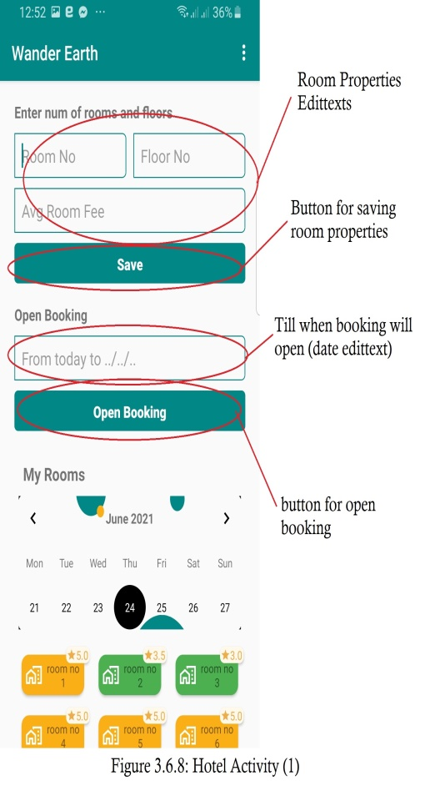 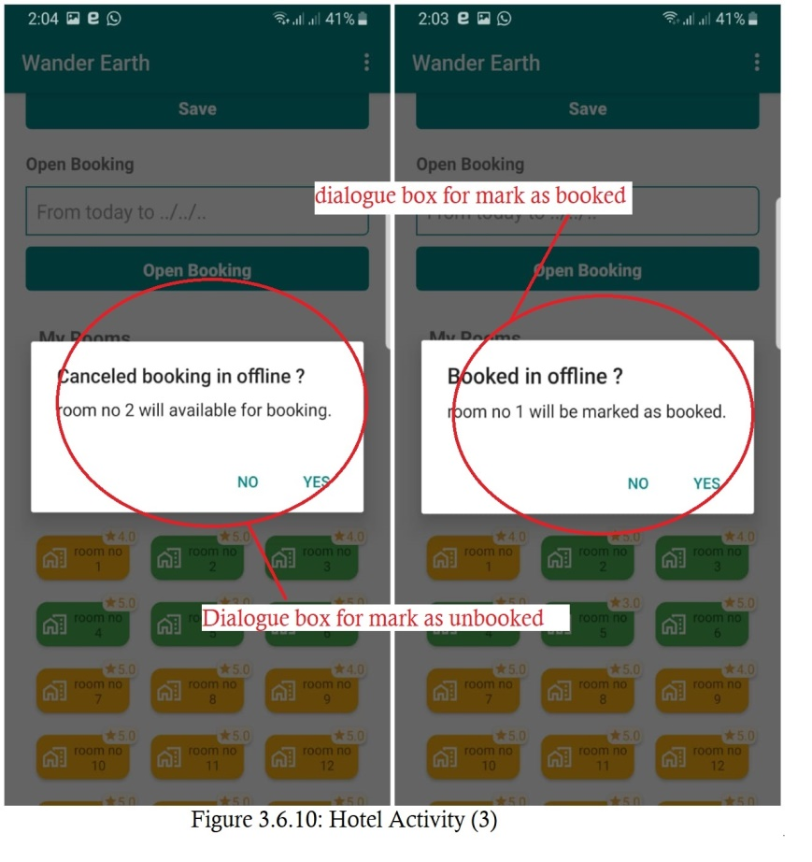 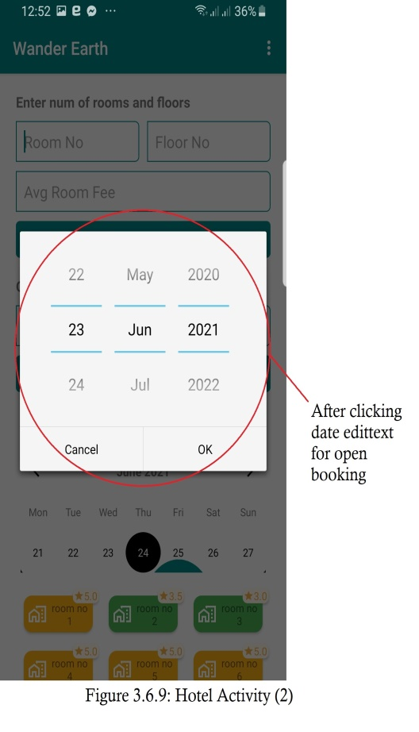

4.Target vs. Actual Accomplishments:

The target has almost achieved during the project. I hadn’t have a plan to add rating for rooms. The course teacher suggested me to add that feature and I had added this. In future, I have a plan to add payment gateway like sslcommerz after making a deal with them. I have also a plan to add country and district spiner on top of select hotel spinner on consumer id. The user profile also can be added in future.

5.Risk and Issues:

We have to check payment properties more and more to check if there is an issue, because payment is a very sesitive thing. We have to check the cases if there isn’t a field in database we are trying to access and we have to make sure that the app doesn’t crush. The database logics have to be checked more and more. I have used system preference to keep logged in the app, we have to check if there is any security issues or risks.

6.Discussions:

To make the application interactive, different controls have been used and designed using the layout file. Following are the important controls that are designed and used in this application:

* **Text View:** The text view component belongs to the view group as a part of GUI. It displays the text or content view of any activity to the user and allows them to edit.
* **Edit Text:** This allows itself to be editable in the text box.
* **Button:** One of the important components in which the application needs. It is mainly associated with action when the user clicks it. We can represent the button using any text which holds the action class on it.
* **Image Button:** Suppose, if we want to have an image for the button which we have designed, we can include using this control by adding the source or path of the image file within the tags in the layout file.
* **Recycler View:** This is a key component under the view group which helps in displaying the information about anything when we click the action button. It also allows us to scroll through the screen and have a look about the information displayed. Using the list adapter, the content is pulled from the database.
* **Spinner:** It is just a drop down list similar to what's seen in other programming languages such as in HTML pages.Spinner is used to select one value from a set of values. In the default state, a spinner shows its currently selected value.
* **Material Calender View:** It is a simple and customizable calendar widget for Android based on Material Design. The widget has two funcionalities: a date picker to select dates (available as an XML widget and a dialog) and a classic calendar.
* **Menu Button:** The app Menu Button makes it possible to add buttons to the screen of your device and use them for all kinds of features: raise or lower the volume, return to the home screen, go to the options menu, open an app, control the rotation, and much more.
* **Snackbar:** Snackbar in android is a new widget introduced with the Material Design library as a replacement of a Toast. Android Snackbar is light-weight widget and they are used to show messages in the bottom of the application with swiping enabled. Snackbar android widget may contain an optional action button.
* **Toast:** This is a small message displayed on the screen, similar to a tool tip or other similar popup notification. A Toast is displayed on top of the main content of an activity, and only remains visible for a short time period.
* **Cardview:** CardView is a new widget in Android that can be used to display any sort of data by providing a rounded corner layout along with a specific elevation. CardView is the view that can display views on top of each other. The main usage of CardView is that it helps to give a rich feel and look to the UI design.

7.Conclusion:

I have learned a lot from this project on how to develop Android Application and publishing it in real time, use Firebase database, payment, SDKs, graddles. I have also learned how to fix errors and bugs of a project. If people use Wander in the future, their travelling will more easier and their time will be saved. I hope that this experience of developing a project will help me in future.

8.References

1. <https://developer.android.com/>

2. https://material.io/design/

3. https://fonts.google.com/icons

4. <https://www.udacity.com/> (Android Courses)

3. <https://stackoverflow.com/>

5. https://www.youtube.com/